 | Nouvelles Salésiennes  Salesian News  APRIL 2012 AVRIL No.152  Bulletin mensuel électronique  sdbsem@videotron.ca

SHERBROOKE. Le Recteur Majeur (supérieur général) des salésiens, Don Pascual Chavez, a donné comme thème de réflexion à la Famille salésienne en cette année 2012, La Connaissance et l’Imitation de Don Bosco. Ceci en préparation aux fêtes du bicentenaire de la naissance du saint en 2015. On a appelé Don Bosco, père de la jeunesse, père des orphelins, etc. Je lisais récemment la fiche de formation des salésiens coopérateurs de France (rédigée par le p. Edmond Klenck) intitulée À la Recherche de Dieu-Père. Je crois qu’un extrait vaut la peine d’être cité :
« Le P. Desramaut note, dans sa biographie de Don Bosco : Giovanni mesurerait bientôt le malheur de n’avoir plus de père....Il ne trouverait pas au foyer l’être irremplaçable auquel un garçon cherche à s’identifier. Sa quête d’un père parmi les prêtres, les maitres, les supérieurs laïcs ou ecclésiastiques et jusqu’auprès du pape de Rome, serait permanente » (page 15).
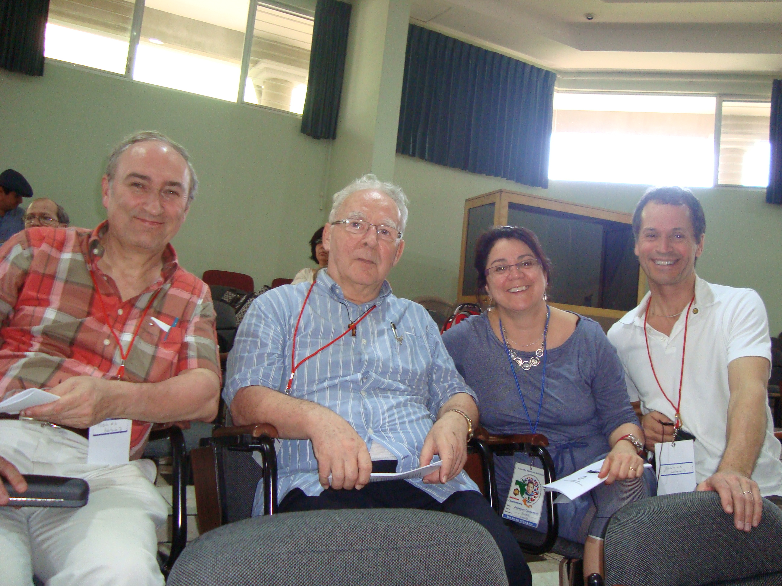
« Notons pour commencer que le père joue dans l’existence de chacun un rôle prépondérant (réalité qui n’est pas assez prise en compte dans les familles monoparentales ou les couples homosexuels qui adoptent un enfant).
Dans la première enfance, la relation avec notre père – et de façon plus générale, avec nos parents - inscrit dans notre inconscient des images mentales que nous projetons par la suite sur d’autres objets. Si on dit à un enfant que Dieu est notre Père, il va reporter sur Dieu l’expérience qu’il fait de la paternité d’ici bas. S’il a un père exigeant, sévère, qui le réprimande et le punit, il va reporter cette image paternelle sur Dieu qui deviendra alors un Dieu juge, surveillant, gendarme, à l’affut de la faute.
Si, par contre, il a un père cool, qui le laisse faire ce qu’il veut et accède à tous ses désirs, « son » Dieu deviendra un Dieu-bon-papa qu’il maniera à sa guise. Nous comprenons facilement que ces images, appliquées au Père des Cieux, ne sont guère compatibles avec celle que nous présente Jésus : Qui me voit, voit mon Père. dit Jésus à Philippe. »
En ce qui concerne la vie au Séminaire et en communauté, voici quelques événements. Le 10 mars, quelques jours après la reprise des cours après le congé d’hiver, les 20 jeunes des JMS (Jeunes Missionnaires du Salésien) sont revenus tout enthousiastes et bronzés de Mexico City, rapportant avec eux d’agréables souvenirs et une certaine nostalgie d’où ils venaient de séjourner dans une maison salésienne de jeunes défavorisés.
À une semaine d’intervalle, le p. Roméo se trouvait à Montréal, tout d’abord pour une rencontre de la consulte de la Famille salésienne en vue de la rencontre du 14 avril, puis pour un conseil provincial des salésiens coopérateurs. Parmi autres choses, il fut question du congrès de San José au Costa Rica, puisque 3 des membres du conseil y participèrent au début de mars.
La délégation du conseil provincial des salésiens coopérateurs à San José, Costa Rica : Pierre Larocque, Roméo Trottier, sdb, Johanne Carpentier, Fernand Lareau.

Les frères Marcel et Gérard étaient présents aux célébrations de la fête de saint Joseph le 19 mars à l’Oratoire St-Joseph du Mont-Royal. C’était la 1ère fois qu’ils y allaient depuis la canonisation du Fr. André. - Le p. George représentait la communauté à la Fête de la Province à Orange, NJ, le 24 mars, participant aussi à la rencontre des directeurs. – Notre « petite retraite » ce mois-ci s’est vécue autour du thème de la strenna 2012; connaître et imiter Don Bosco. Nous avons visionné la vidéo produite par Missioni Don Bosco de Turin portant sur le commentaire du Recteur Majeur. Un partage intéressant s’ensuivit, faisant appel aussi à l’expérience personnelle des confrères.
En préparation aux fêtes de Pâques, le sacrement du pardon est offert ces jours-ci aux élèves du 1er cycle. Le temps d’une période de cours fut consacré antérieurement à une catéchèse sur ce sacrement.- Dans un tout autre ordre de choses, la communauté a étudié les bilans financiers 2011 de la communauté et du Camp Savio, comme il est coutume de le faire chaque année dans chaque maison.
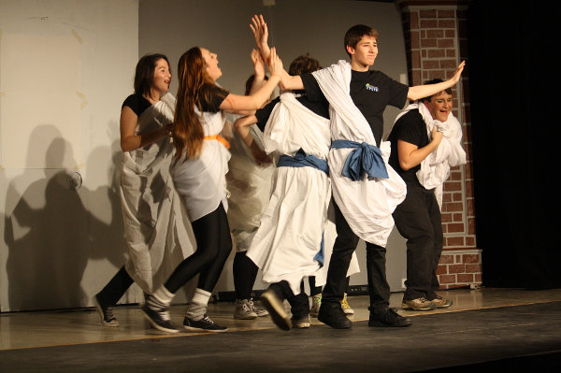
Tout Shakespeare pour les Nuls
(épisode de Jules César)

La saison du théâtre au Salésien bat son plein. Mars vit la présentation de 3 pièces : Le Divan (par les élèves de la 1re sec.), Tout Shakespeare pour les Nuls (3e sec.), Visa pour l’Éternité (4e sec.).- Quatorze équipes du Salésien (sur 42 en tout) se présentèrent à l’Expo-sciences Régionale qui s’est tenue à l’Université de Sherbrooke. Des Newton, Bell et Gates en herbe!
À chacun/e des lecteurs de NS/SN, une lumineuse et réjouissante fête de Pâques! (R.T)
TORONTO.
March, the Month of Lenten Fervour
While Lent brings the usual increase in confession ministry and devotions such as Stations of the Cross, our Salesian presence in Ontario during March takes on a much wider circle of activity.
In promotion of vocations, St. Benedict Parish sponsors a table at the Archdiocesan Ordinandi Dinner, inviting especially those involved in Salesian youth ministries. Soon after, Fr. Dominic Tran, Province Vocation Director, along with Bro. Bernie Dubé, offers a Come and See vocation discernment weekend for four young adults.
During the third week of Lent, Fr. Mike Pace preaches a mission at Holy Name of Jesus Parish in Laval (Montréal).
In preparation for First Communion, a team of St. Benedict staff and parishioners give candidates and their families a tour of the church from choir loft to sacristy, with particular attention given to the sanctuary and altar. Candidates also make First Penance this month.
Meanwhile, with daylight savings time and the arrival of spring, serious planning for SummerDaze camp takes the form of a careful selection of administration and staff. So also, work is progressing toward the introduction this summer in Toronto of Gospel Roads I.
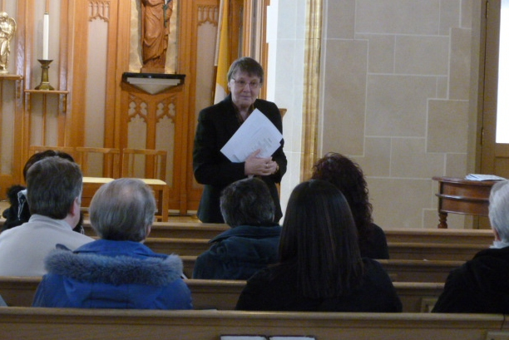
Sister Kathleen Taylor, FMA, addressing members of the Salesian Family.

Even in this busy month, certain highlights stand out with special brilliance. Sunday, March 4, sees the revival of Salesian Family Day. Sister Kathleen Taylor of the Salesian Sisters’ General Council graces the meeting for SDB, FMA, Cooperator Salesians, ADMA, and Past Pupils with her presence and a presentation on the most recent document, Charismatic Identity Card of the Salesian Family of Don Bosco. A much larger gathering, sponsored by the Salesian Youth Ministry Office, follows this first meeting. It features bestselling author, television commentator and columnist, Mr. Michael Coren, reviewing points he makes in his acclaimed book, Why Catholics Are Right.
From Thursday, March 15 to Sunday, March 18, Fr. Joseph Occhio is visited by his nephew, Mr. Sergio Occhio and his family who come from Bergamo, Italy.
Congratulations go to Bro. Bernie Dubé who celebrates 63 years of life on the Feast of St. Joseph, March 19. We continue to pray for his health as we do also for Fr. Joseph Ho who remains in Hong Kong, regaining his strength.
Community & collaborators celebrating Bro. Bernie’s birthday.

Fr. Drago Gacnik at St. Gregory the Great Slovenian Catholic Church in Hamilton receives greatly appreciated help in the form of Fr. Bogdan Kolar who is spending a few weeks doing research for a parish history and for a history of Slovenians in Canada.
Finally, our community is well represented at Province Day in Orange, New Jersey, on Saturday, March 24, by Bro. Bernie Dubé and Frs. John Puntino and Michael Pace, present also at Stony Point on the previous days for the semi-annual Directors and Pastors Meeting. (JP)
====================
MONTREAL. The confreres directly involved in pastoral and catechetical ministry together with the collaborators in the parish and at the youth centre met twice to reflect on the theme of evangelisation in the various sectors of our youth ministry. The objective was in the sense of being more efficacious regarding the families of our young people and the young people themselves, especially after Confirmation.
The couples already engaged who will celebrate their marriage in the course of the year number 45. They follow a course of preparation held here in the parish; it consists of 3 meetings of about 4 hours each on Sundays.
A very interesting meeting took place in February with Sr. Kathleen Taylor, a member of the General Council of the Salesian Sisters in Rome. She talked to a good group of the Salesian Family on the theme of the Salesian Family.
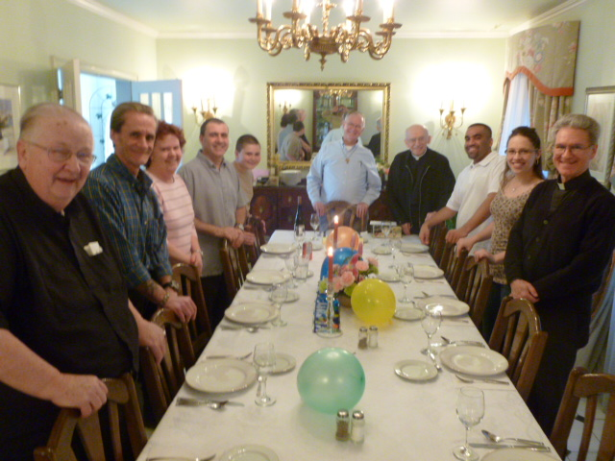
The confreres held their monthly day of retreat at Pierrefonds at the Villa St-Martin; the theme studied was that of the 2012 strenna: To know and imitate Don Bosco.
In March, about 100 young people from various parishes of Montreal, guided by young animators of the Net Ministry Movement, met at our Youth Centre with some 50 young people of our JPII Club for an evening of prayer and friendship.
Another important event of our parish life was the election of the members of our Administration Council. – With the passing of March ends also the catechism programme for the children preparing for First Communion and Confirmation. The various celebrations of these sacraments are scheduled on weekends immediately after Easter. (E.T.)
===========================

SURREY, B.C. March didn’t exactly arrive like a lion here in Surrey, but it was darn right brisk, breezy and brash. This dingy weather system didn’t hinder the Salesian Cooperators’ 10th Annual 3 on 3 Basketball Tournament held in the Don Bosco Gym with over 46 teams participating. It was an exciting all day event filled with enthusiasm, volunteers, and something for everyone of all ages to the tune of almost 1000 persons attending. The Praise Team took care of the concession stand with the proceeds going toward their cause.
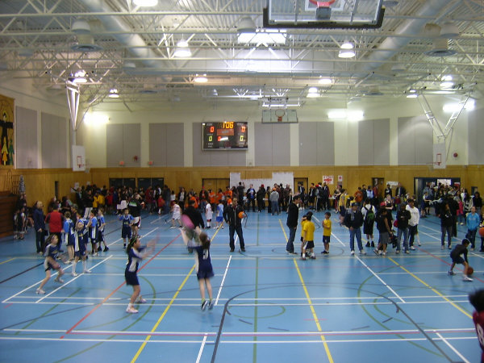

3 x 3 Basketball tournament in Surrey, B.C.

Hourly door prizes added to the adventure, and medallions were won by the various age winners. Under the direction of Mr. Paul Dumas and his youthful referees, they accomplished an outstanding job of arranging the scheduling for the various games, court supervision, score keeping, timing and posting. What an excellent and professional achievement! Numerous members from all the various organizations contributed in some way to the success of this wonderful event. For the younger set, ice cream, a wheel of fortune, prizes, games, awards and face painting, along with clown’s Click and Push Cart, a colourful Junior Sport Games, which were actually five games in
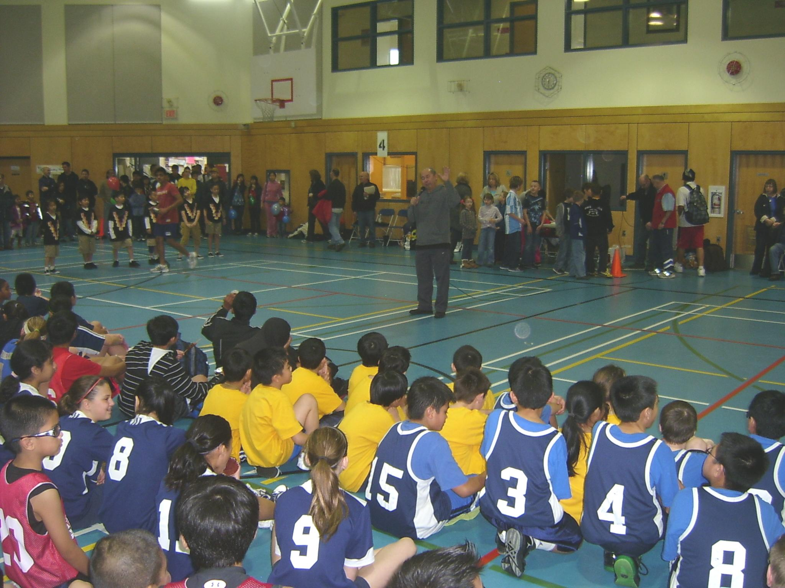
Fr. Mario addresses the “athletes” of 3 x 3. Basketball Tournament

one spot; by rotating, a child could play Basketball, Darts & Frisbees, Soccer, Baseball or Football, a jumping bean castle, plus balloon sculpture. The day also included a mid-afternoon “pep rally” conducted by Fr. Dave with a gym court-parade of the team members. Certainly our hats go off to our organizers, the Salesian Cooperators, for this very enjoyable Salesian, energy-filled event.
The second weekend in March was just as busy here at OLGC with 142 Kids for Christ in the Don Bosco Youth Centre for their Pre-Conference “Let’s Go!” Another 60 plus Youth for Christ service members were present to facilitate the overnight retreat camp. They all heartily attended the 7 pm Saturday night Youth Mass with Fr. Dave as the Celebrant. Meanwhile in our renovated convent, now known as our Discernment House, under the direction of Sr. Cora Beboso, FMA, (who travelled from Toronto) to conduct the 1st “Come and See” Discernment Weekend for 13 young women who happily seemed to enjoy this special occasion and crowning event for Western Canada.
This weekend was also the launching pad for our Young Caglieros Outreach Movement (named after Bishop John Cagliero, Don Bosco’s first Salesian missionary) whose purpose is to attract young adults from the ages of 19 thru 30 years old to go on a mission experience in the Philippines. They will be part of a team that will build houses for poor families, develop their leadership skills while making friends and ultimately live out their faith in action. This new venture here at OLGC is being sponsored by the Salesian Cooperators, Couples For Christ (CFC), Youth and ANCOP (Answering The Cry Of The Poor) whose CFC Program builds shelter, educational and sponsorship to children and the poor. Colourful brochures were handed out after all the Masses with a short announcement given by a young adult representative before the final blessing and conclusion of each Mass. A Thursday evening meeting was scheduled in the Don Bosco Youth Centre for all interested persons who would like to be a part of this rocketing missionary endeavour.
In the same vein our former World Youth Day participants are already planning their own mini World Youth Day Preparation Program right here at home base with the hope that more young adults will be able to attend the Rio de Janeiro event in the summer of 2013. They are arranging their own Salesian pilgrimage, looking into scheduling, travel, etc. and all the wonderful things that go into making such a world wide event successful.
In preparation for the feast of St. Joseph, patron of Canada and also of the Salesian Congregation, Fr. Mario held a novena in his honour. For 9 days during all the Masses prior to the feast day, instead of the customary Prayers of the Faithful, the Litany of St. Joseph was recited. It was an inspiring tribute to St. Joseph, guardian of families.
FREEDOM 2012, the original Reconciliation event for youth and young adults was offered this year at Good Shepherd Church in Surrey. Frs. John and Dave were present for administering the Sacrament after all participants experienced first hand the healing of Christ through music, prayer, testimonies and teachings. This event is sponsored by the Archdiocesan Office of Youth and Young Adult Ministry. - Very Rev. Darek Bartocha, SDB, Fr. Jan’s provincial from Poland, arrived late Friday evening to preach the Polish Community’s retreat. He was treated to a Sunday afternoon reception. After that long trip, Fr. Darek was given the opportunity to rest, and later shown some of the Vancouver sights. Confessions were held on the last evening of the retreat with the help of some of the local Polish clergy. All, including the Salesians, were treated to a delicious home-made Polish supper prepared by the Polish Ladies Guild. It was quite the treat!
The Catechesis of the Good Shepherd, sponsored by the Archdiocese of Vancouver, was held at OLGC School Library for the duration of a week. Thirty brave educators from throughout the diocese gave up their Spring Break to participate in this new venture being launched with the blessing of our Archbishop Michael J. Miller. Msgr. Jensen was the main celebrant for their opening Mass. The instructors: Mrs. Susan Perna from Toronto (over 30 yrs. in the program), and Mrs Nancy Wood from Winnipeg (who has been working for 20 yrs. in this Montessori Method) were housed in our Discernment Residence for the duration of the sessions.
For the feast day of St. Patrick, our Spring daffodils, hyacinths and crocuses on the East side of the Church began blooming. The cherry, apple and forsythia tress are already in the budding stage, and I am sure will make their beautiful appearance in time for Easter.
Fr. Mario attended the Directors’ meeting and the Province Day Celebration in Stony Point, NY. - We recently welcomed our guest, Bro. Antonio Caspellan, SDB, from the Philippines. He is visiting his older sister who resides in Richmond for a few weeks as she battles cancer.
While the priests were busy each evening helping with the Sacrament of Reconciliation in the various parishes of our deanery, Bro Jerry was the presider on the last Thursday of the month for the Knights of Columbus Marian Prayer Program. About two dozen Knights and their families attended the hour-long service honouring Our Lady of Guadalupe. It consisted of one of the many framed pictures of her under that title that was officially blessed by the Holy Father, displayed centre stage in front of the main altar with an opening Marian Hymn, Scriptural Readings, a Reflective Talk, a Period of Silence, Prayer Intentions, the Rosary followed by the Litany of Our Lady and concluding with an appropriate Prayer. This event is a prelude to the 2nd Guadalupe Festival that will be held at the Los Angeles Coliseum August 5, 2012 and is being sponsored by the Knights of Columbus International.
The last day of March held two outstanding events. “Living The Eucharist”, a half-day Lenten Retreat sponsored by the Perpetual Eucharistic Adoration Ministry, was held in the church and our Mary Help of Christians Hall. The presenter was Mr. Kyle Neilson, Director of the Office of Evangelization for our Archdiocese. The mini retreat was open to all parishioners and their families. It consisted of time for meditation and prayer concluding with a Potluck Lunch.
That afternoon El Shaddai members from across British Columbia attended their 5th Anniversary Year Celebration with an afternoon Mass with Fr. Mario as the main celebrant. Entertainment, door prizes and supper followed in OLGC School Auditorium. All the Salesians were cordially invited with Bro. Jerry leading the customary blessing of the food in song to the tune of “Edelweiss.”
Earlier in the day the Polish Saturday Language School made decorative branches in preparation for Palm Sunday’s welcome of Our Lord’s entrance into Jerusalem. Designed with wax and various food dyes, the colouring of Easter Eggs, plus small lambs made out of cheese to enhance their Easter Baskets. Besides all the various other meetings, church cleaning for Easter, etc. the busy month of March went out like a lamb. (J.H.)
===========================

HAITI- Fort Liberté: un nouveau pavillon pour la formation des jeunes

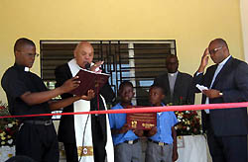
Le dimanche 4 mars, l’œuvre salésienne de Fort Liberté, dans la zone nord-occidentale de Haïti, a célébré plusieurs événements: l’inauguration des nouvelles structures de l’École de Sciences Infirmières; la remise des diplômes au 3e cycle d’étudiants de cette même école; la prise de coiffe des étudiants de la deuxième année et une commémoration des 75 ans de présence salésienne en Haïti et des 10 ans à Fort Liberté, une œuvre endommagée par le séisme de janvier 2010.
La journée commença par la messe dans la Cathédrale Saint-Joseph de Fort Liberté, présidée par Mgr Louis Kébreau, sdb, archevêque métropolite de Cap-Haïtien, et concélébrée par le supérieur de la Quasi-Province d’Haïti, père Sylvain Ducange, et une douzaine d’autres prêtres. Les enfants et les jeunes du Centre Polytechnique Don Bosco étaient présents par centaines.
Dans son homélie, Mgr Kébreau a exhorté les jeunes à valoriser leur vie en renonçant à la futilité et à la vanité du monde. Faisant référence aux lectures du 2e dimanche du Carême, fête de la Transfiguration, le prélat a souligné la transparence et la proximité de Dieu dans le mystère de la Trinité et de l’amour.
Il a conseillé aux jeunes de ne pas gaspiller la beauté reçue de Dieu en échange d’accessoires inutiles, mais de manifester la beauté et la transparence de Dieu par leur vie et leur comportement. Il a ajouté que la jeunesse est la richesse principale d’Haïti et le meilleur cadeau qu’elle peut recevoir, c’est l’éducation, afin d’éviter de se perdre et ainsi demeurer près de Dieu et lutter chaque jour pour devenir de “bons chrétiens et d’honnêtes citoyens”. (ANS 14/03/2012)

++++++++++++++++++++++++++

FRANCE : les salésiens et les Filles de Marie Auxiliatrice, ensemble en mission

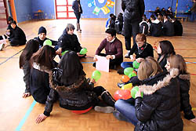
Depuis sept ans maintenant, les salésiens et les Filles de Marie Auxiliatrice conduisent ensemble une semaine de mission, se rendant dans un établissement scolaire pour vivre avec les élèves et les adultes divers temps d’animation. Cette année, cette mission s’est tenue à Wittenheim, en Alsace. Le thème était: “Apprenons à donner des couleurs à nos vies!”
La consigne donnée aux missionnaires avant de partir, c’était d’aider les jeunes qui ne se parlent pas ou forment des clans à se rencontrer. Dans ce but a été organisé un grand jeu par équipes – chacune caractérisée par une couleur – qui a permis de diviser et de mélanger entre eux tous les élèves. Ensuite au moyen de plusieurs activités ludiques, comme la course en sac, le passage d’une rivière à pieds-secs, des quizz sur Don Bosco et Mère Mazzarello, etc. on a favorisé l’échange et le partage. Au fur et à mesure que les journées s’écoulaient, un grand puzzle se construisit sur un mur du gymnase figurant le mot VIE.
Les élèves de Wittenheim, au nombre d’environ 500, provenant souvent d’expériences d’échec scolaire, ont accueilli les missionnaires avec une grande curiosité et un sincère enthousiasme. Ils étaient heureux d’être écoutés et mis en valeur, et au cours des nombreux échanges informels avec les salésiens et les fma, ils ont enrichi leurs horizons et acquis de nouvelles perspectives.
En voici un exemple : deux collégiens parlent avec une jeune sœur de la vocation religieuse. L’un d’eux interpelle l’autre : “de toutes façons, un voyou comme toi ne peut pas être religieux!”. Et la sœur de dire : “Eh bien! tu te trompes” et elle leur raconte la vie du jeune Michel Magon. L’élève traité de voyou par l’autre, ravi, a pris l’initiative de rejoindre l’équipe des missionnaires à la messe qui commençait
Le dialogue entre les jeunes et les religieux a été constant et fécond. Un spectacle sur Jésus, monté par l’équipe de la mission en partenariat avec l’équipe pastorale de l’établissement, fut l’occasion d’un échange entre religieux et jeunes qui se sont exprimés avec une grande franchise : “Pourquoi avez-vous choisi ce métier? Vous n’avez pas le droit d’avoir une famille? Vous n’avez pas le droit d’avoir de relations sexuelles? Combien vous gagnez?”, ou bien “Les époux doivent vivre, eux aussi, la pauvreté, l’obéissance, et la chasteté ?” Voilà quelques questions qui ont été posées aux personnes consacrées.
Parmi les thèmes abordés au cours de la semaine, il y eut également celui de la violence. Le père Olivier Robin a expliqué à l’équipe éducative comment la gérer, aussi bien celle qui est en nous que celle que nous voyons chez les jeunes. Ses réflexions ont beaucoup frappé les professeurs qui ont décidé de poursuivre ces réflexions entre eux.
Les anciens élèves et les salésiens coopérateurs ont également participé aux activités, réalisant un spectacle de cirque. Et bien sûr, une grande attention a été donnée à la dimension spirituelle de la mission: des moments de prière animée, des célébrations simples, joyeuses et en même temps

recueillies. Les missionnaires ont aidé les jeunes à approfondir cette dimension souvent négligée de leur vie. (ANS le 03/04/2012)

+++++++++++++++++++++

HEUREUX ANNIVERSAIRE!

p. Dominique Britschu : 1 mai : Ordination

p. Luc Lantagne : 3 mai : naissance

p. Paul Cossette : 7 mai : naissance

++++++++++++

JOYEUSES PÂQUES
HAPPY EASTER
FELICES PASCUAS DE RESURRECCION
XRISTOS ANESTI

+
+++++
+
+
+

